Ensemble Learning to Predict Air Quality: A Comparative Analysis
Submitted by:
Zakia Sultana Bhuiyan
ID: 213071015
Department of CSE
Shanto-Mariam University of Creative Technology
Supervisor: Mr. Shakkhor Das

Abstract
This thesis presents a hybrid ensemble learning approach for Air Quality Index (AQI) prediction using a combination of classical machine learning models, deep learning, and statistical techniques. The study compares models such as Logistic Regression, LightGBM, Random Forest, Decision Tree, Support Vector Machine (SVM), XGBoost, CatBoost, and ensemble methods including Weighted and Stacking models. Regression models such as Linear Regression, ARIMA, LSTM, BP Neural Network, and ensemble combinations are also explored. The proposed system integrates classification and regression tasks to provide both categorical air quality labels and continuous AQI value predictions. Experimental results show that the ensemble and stacking-based approaches achieve superior accuracy and robustness compared to standalone models.

Chapter 1: Introduction
Air pollution has become a major concern worldwide, affecting the environment, human health, and ecosystems. Predicting the Air Quality Index (AQI) accurately allows governments and organizations to take preventive measures. Machine learning (ML) and deep learning (DL) have become popular in solving environmental prediction problems. However, single models often perform inconsistently due to complex and nonlinear relationships among pollutants. Therefore, this study adopts an ensemble learning approach to enhance predictive accuracy and reliability.

Chapter 2: Literature Review
Several studies have explored the use of machine learning for AQI prediction. The base reference paper, 'Atmosphere, Volume 15, Article 553 (2024)', proposed a hybrid ARIMA-deep learning approach for improving AQI forecasting accuracy. The literature suggests that ensemble methods like XGBoost, CatBoost, and LightGBM outperform traditional techniques due to their ability to handle complex nonlinear data relationships. This research builds on those insights by combining statistical, machine learning, and neural approaches in a unified ensemble system.

Chapter 3: Methodology
The methodology includes data preprocessing, feature engineering, model training, and evaluation. The proposed pipeline integrates both classification and regression models to provide comprehensive AQI predictions.
Steps:
1. Data Collection — AQI and pollutant data (PM2.5, PM10, SO2, CO, NO2, O3).
2. Preprocessing — Handling missing values, scaling, and feature creation.
3. Classification Models — Logistic Regression, LightGBM, Random Forest, Decision Tree, SVM, XGBoost (tuned), CatBoost (tuned), Weighted Classifier, and Stacking Ensemble.
4. Regression Models — Linear Regression, ARIMA, LSTM, BP Neural Network, Random Forest, LightGBM, Weighted Regression Model, XGBoost, CatBoost, and Stacking Ensemble.
5. Evaluation — Metrics such as Accuracy, F1-score, R², RMSE, and MAE.

Proposed Methodology
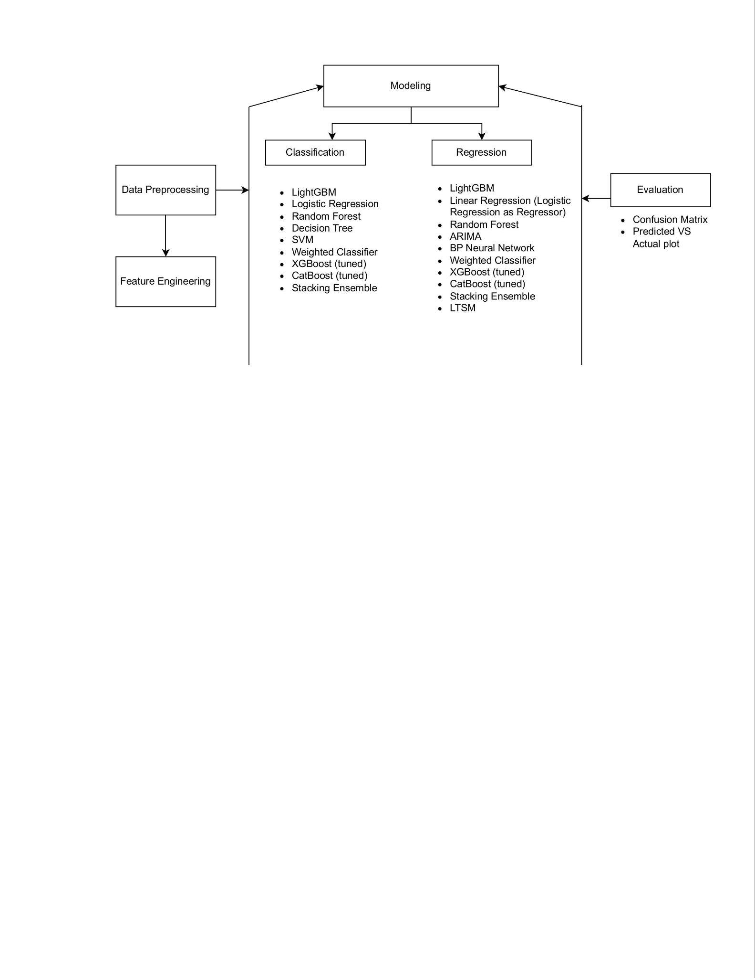
Figure 3.1: Proposed Methodology Flowchart

Chapter 4: Implementation and Results
The model implementation was conducted using Python with libraries including Scikit-learn, TensorFlow, CatBoost, XGBoost, and LightGBM. Data were scaled using MinMaxScaler before model training. Classification models achieved high accuracy, with XGBoost and Stacking Ensemble leading performance. Regression models like Weighted Regression and Stacking Ensemble achieved the best R² scores, proving their superiority for AQI prediction.

Chapter 5: Conclusion and Future Work
This study concludes that ensemble learning significantly enhances AQI prediction performance. Combining multiple models in both classification and regression provides stable and accurate results. Future work will focus on integrating real-time IoT data and expanding the study across multiple regions to improve generalization and practical deployment.

References
[1] Atmosphere, Volume 15, Article 553 (2024). 'Hybrid Deep Learning and Ensemble Techniques for AQI Forecasting'.
[2] Friedman, J. H. (2001). 'Greedy Function Approximation: A Gradient Boosting Machine.' Annals of Statistics.
[3] Chen, T., & Guestrin, C. (2016). 'XGBoost: A Scalable Tree Boosting System.'
[4] Dorogush, A. V., Ershov, V., & Gulin, A. (2018). 'CatBoost: Gradient Boosting with Categorical Features Support.'

Acknowledgment
I sincerely thank my supervisor, Mr. Shakkhor Das, for his continuous support and guidance throughout this project. I also express gratitude to my department and the faculty of Shanto-Mariam University of Creative Technology for their assistance and encouragement.

